

kokhanok village council

Youth and the Electric Utility



Utility management assistance Contract #

ACEP Technical Monitor: Gwen Holdmann

December 31, 2020

Youth Involvement In Electric Utility

Table of Contents

Reinventing Fire and the Future of Power in Rural Alaska 3

Forward 3

Introduction 4

Activity: Elder/Historian Interviews 5

Unit 1 My Electric Utility 6

*Materials:* 6

Activity: Site Visits 8

Activity: Electric Utility Jobs 8

Unit 2 Electric Math – Math with Purpose 9

Activity: Subtraction of up to 5-Digit Numbers for Customer Usage Calculation 9

Activity: Calculating the Cost of Power - Multiplying Money by 3 and 4-Digit Numbers 10

Activity: The Power Cost Equalization Subsidy – Subtracting Money 12

Activity: Averages, Weighted Averages, and the Price of Fuel 13

Activity: Depreciation - Dividing money by 1 and 2-digit divisors 15

Activity: Fuel Efficiency - Division 16

Activity: Line Loss – Subtraction and Division 18

Unit 3 Electric Utility Newsletter 19

Worksheet: Pre-Utility Site Visit Vocabulary 20

Worksheet: My Electric Utility 21

Worksheet: Electric Utility Jobs 24

Customer Meter Photos – Quyana to Akiak Power Company! 26

Worksheet: Usage Calculation - Subtraction with 5 Digit Numbers 32

Information Sheet: Customer Rate Classes 33

Worksheet: Calculating Cost of Power - Multiplying Money by 3 and 4-Digit Numbers 34

Worksheet: Power Cost Equalization Subsidy - Subtracting Money 35

Worksheet: Depreciation - Dividing money by 1 and 2-digit divisors 36

Worksheet: Fuel Efficiency - Division 37

Worksheet: Line Loss – Subtraction and Division 38

ANSWER KEY 39

# 

# Reinventing Fire and the Future of Power in Rural Alaska

## Forward

Like a lot of Alaska, Kokhanok is a beautiful place on the planet and blessed with plenty of good food available for a subsistence lifestyle. Located on the south shore of Lake Iliamna, the Kvichak River is their backyard. The Kvichak connects the Lake to Bristol Bay. Sockeye Salmon are the lifeblood of this generous ecosystem.

The winds off Lake Iliamna provide a steady energy resource with an occasional big blow, but little turbulence. It’s an enviable resource that will provide enough electricity from two 90 kW Vestas wind turbines to power the community and make heat with excess wind power - once integration with the diesel plant is done right.

Hybrid power systems are complicated, computers and controllers are a given at the power plant now. Wind turbines require tower climbing skills and strong legs to service. A new generation of operators and management is needed.

Keeping the lights on is the most important job in any remote community. Airports, telemedicine, schools, stores, the comfort of residents and any local economic development all depend on reliable and affordable power. The business of making and selling power is economic development – and can beget more opportunity for development - when done well.

Kokhanok Village Council and the staff of Kokhanok Electric decided to educate, involve, and motivate youth through their electric utility business. The best way to teach is to connect learning with real life. We aim to make our electric utility the training ground for future generations of entrepreneurs, technicians, engineers, bookkeepers, and managers.

## Introduction

We humbly ask teachers, students, and community members to think about – and some may remember - the evolution of fire into electricity in your community. “Humbly” is used to emphasize the enormity of this accomplishment.

Think about life if humans had not used the ability to make fire to create the combustion engine and then generate electricity. And think about how life would be different if the State of Alaska had not taken up the task of developing centralized power systems for every rural community.

Research the evolution of fire in your community. Learn about the business of keeping the lights on, what skills it takes, and why electricity costs what it does. Envision the future of power in your community. Will you have a role in that future?

Keeping the lights on in rural Alaska for generations to come will require innovation, a well-trained local workforce, and an informed and supportive community.

We hope to hear from other students around Alaska about what is being done by youth elsewhere to help keep the lights on.

### Activity: Elder/Historian Interviews

Materials: clipboards, paper with 1-2 questions per student being asked, recording device

Invite speakers into the classroom, and/or assign students homework to do interviews. Direct students to tape record the interviews for accuracy. Video is another option. Both require permission from the interviewee. Edit, illustrate, then share the stories in an electric utility monthly newsletter.

Brainstorm questions to ask as a class before doing the interviews. Don’t overwhelm folks elders being interviewed, each student could focus on just a few questions from the list to discuss deeply with their chosen historian(s).

*Be sure to get a signed waiver from those being interviewed allowing use of their interview/image in a local utility newsletter.*

Sample Questions:

* How did your grandparents keep their homes warm and lit in winter?
* Did you yourself ever live without electricity?
* Did you ever live with just a small generator at your house?
* Did kids sleep more when you were young than they do now because there was little or no power? How about when your parents/grandparents were young?
* What did people do for fun in the evenings when you were young?
* What kinds of appliances did you have that could work with a home generator?
* Do you remember when the first central power plant was built here?
* What was the hardest part about not having electricity from a central power plant?
* Was there anything you liked better about not having electricity?
* Do you think it would be cheaper to make your own power or to buy from the utility like now?
* Would you want to make your own electricity again?
* What do you like best about having an electric utility?
* What do you like the least about having an electric utility?
* Do you have a pre-pay electric meter? Do you like it or not like it? Why?

Return back to the classroom and discuss answers. Have student’s share what questions they asked and responses. What did student’s learn? Compile into one working document to share with village council, LSAC (local school advisory committee) or newsletter.

## Unit 1 My Electric Utility

Students go visit the local electric utility to learn where and how electricity is generated, where the fuel comes from, what each person at the utility does for their job, and how what they learn at school relates to this work.

Encourage students to thank the workers for all they do to keep the lights on for the community.

### *Materials:*

*Pre-Site Visit Vocabulary Test*

*My Electric Utility* worksheet

*Electric Utility Jobs* worksheet

Clipboards

Pencils

It takes some special skills to run a successful utility. Managers and clerks are responsible for power sales, tracking income and expenses, reports to the Alaska Energy Authority (AEA) and the Regulatory Commission of Alaska (RCA), and customer relations. Power plant staff maintain, operate, and repair generation equipment and the **distribution system** – everything from the diesel power plant, along the electric wires, **transformers**, and right up to the **meters** on every customer building and home.

A locally owned and well-operated electric utility can provide long-term, good paying, and meaningful local jobsIt is the one business in town everyone wants and needs to be successful. The future of independent power in every village depends on the skills of the local workforce and the collection of sufficient revenue to cover costs. . Do you mean independent businesses depend on a functioning utlilty program or that the utility job is a desired position?..just not clear on this sentence.

#### Vocabulary List:

**Diesel Engine Generator Set / “Gen-Set”** – the combination of a diesel engine with an electric generator to generate electrical energy

**Distribution System** – a network of wires that carries power from the generation plant to customers within a limited area

**kWh** – 100 watts times one hour (the amount of power needed to light a 100 watt light bulb for one hour)

**Microgrid** – a generating and distribution system that serves a small geographic area

**Power Cost Equalization (PCE)** – subsidy provided by the State of Alaska to “equalize” the cost of power between rural communities and Alaska’s Railbelt utilities.

**Transformer** – lowers the power voltage from primary lines to a usable level for customer appliances, equipment and lighting; one transformer can service several customers through *secondary* distribution lines

**Urban** – of, relating to, or designating a city or town

**Gear Up:**

Schedule a field trip for students to the electric utility office. Let the office know you also want to tour the power plant and any other generation equipment (wind farm, solar farm, hydro-plant) to the extent that safety allows for the age group. Provide the *My Electric Utility* worksheet students will be completing to the utility office in advance of the field trip.

Have students study the vocabulary above and complete the *Pre-Utility Visit Vocabulary* worksheet prior to the field trip.

Materials:

Clipboard

Pen and vocabulary worksheet

Any pre-discussed questions

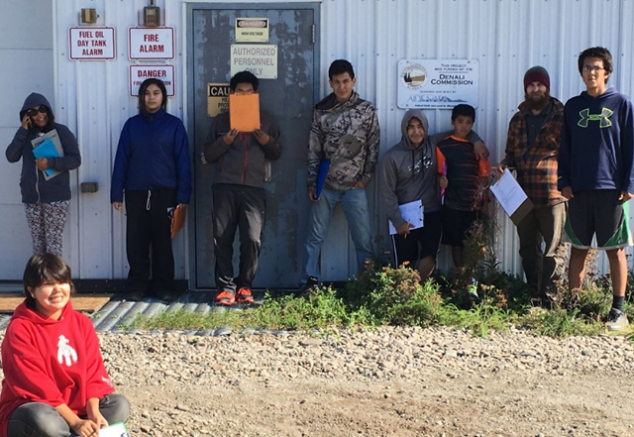

*Kokhanok high school class and their teacher on tour at the community power plant in September of 2016.*

## Activity: Site Visits

Go on a field trip to the electric utility office. Have students take their *My Electric Utility* worksheet and take turns asking the staff for answers to the administrative questions.

Next go to the diesel power plant to interview the operator(s) for answers to the generation questions. If there is a wind farm or hydro-plant nearby go there next. Ask questions prior and after entering the generator house.

Students should practice asking questions in a clear and audible voice in a group setting prior to the field trip. Even the outer room of the power plant can be loud.

## Activity: Electric Utility Jobs

Have students choose one person from the utility staff to interview about their job. Make sure all staff members get chosen, because each job is vital to the success of the utility.If more students than staff, have students work in pairs or groups.

|  |  |
| --- | --- |
| **Job Title** | **Local Personnel** |
| Utility Manager |  |
| Utility Clerk |  |
| Bookkeeper |  |
| Lead Power Plant Operator |  |
| Assistant Power Plant Operator |  |
| Meter Reader |  |

Some sample questions:

* What subject in school was the most helpful to you in your job now?
* What activities might you do during a typical day at work?
* What is your favorite part of your job?
* What is your least favorite part of your job?
* Are there classes or trainings available to help you get better at your job?
* Do you get a pay raise if you stay on the job for years or get more training so you can do a better job?
* How many hours do you work a day?
* How many days a week do you work?
* Are you required to be “on-call”?

## Unit 2 Electric Math – Math with Purpose

Electric utilities are in the business of making power to sell. How much customers pay for power depends on how much it costs to generate, deliver to customers, and to administer (do all the paperwork) for the business of selling power. The total cost is then divided by however many kWhs the utility can sell. That becomes the customer rate.

In Alaska, the high cost of rural power is subsidized by the Power Cost Equalization (PCE) program. The State pays a portion of Residential and Community Facility kWh usage. The level of support for each community is determined by a report submitted annually by the utility to the Regulator Commission of Alaska (RCA). **Careful tracking of expenses, fuel efficiency, and line loss help the utility get a higher subsidy for their customers.**

Good math skills are important to both the employees of the electric utility and the community the utility serves.

## Activity: Subtraction of up to 5-Digit Numbers for Customer Usage Calculation

Example: 45276 current reading

-44747 previous reading

00529 kWhs used

**Background:**

Customers get billed for the kWhs used within a one-month period. Customer usage is measured by meters that record numbers up to 5 digits long. Usage is calculated by subtracting the previous month’s reading from the current month’s reading. The total number of kWhs used is then multiplied by the cost per kWh.

There are two types of **electric meters** commonly found in rural Alaska. Mechanical meters are the old-time versions and are being replaced by new digital meters and even “smart” digital meters in some communities. “Smart” just means they can do more than just measure power. Some can send meter readings to a server either in the community or in Anchorage, eliminating the need for a meter reader. Some smart meters can be set to be “pre-pay”, meaning the customer must pay for power in advance of using it. The meter shows the customer how much money is remaining before the power will be shut off. The dollar amount runs backwards as power is used. We have pre-pay meters in Kokhanok. Most people really like them because they can manage their usage better. Watching your money go backwards is a good reminder to turn things off when not in use – and to figure out what in your house is using the most power.

If you get to follow the meter reader during end of the month readings, you will discover there are five different rate classes.

Digital pre-pay meters are used in the *Customer Meter Photos* included with this unit. The display is typical of other digital meters. Use the photosto answer the questions on the worksheet *Subtraction with 5 numbers for Customer Usage Calculation.*

Standards:

## Activity: Calculating the Cost of Power - Multiplying Money by 3 and 4-Digit Numbers

Example: $0.6245 rate per kWh

X 529 kWhs used

56205

124900

3122500

$330.3605 rounded off equals $330.36 owed to utility

The full cost of power for one month is calculated by multiplying the number of kWhs used by the utility’s electric rate. In the example above the electric rate is $0.6245/kWh and the customer used 529 kWhs of power for the month.

Ouch. $330.36 is a lot of money for one month’s power.

Why is the cost per kWh so high? Making electricity in remote locations all around the world is expensive, more so in some places than others. Why do you think that is? In rural Alaska utility rates vary widely due to population and location.

Coastal communities can get fuel by large barges, making the cost per gallon cheaper than other delivery **modes** (methods). Communities along rivers deep enough can also get boat deliveries, but it may be a smaller and costlier vessel.

A very few communities on the road system are not connected to the Railbelt Grid and must support their own utility. They get fuel hauled in trucks. Landlocked communities not on the road system must rely on flying tankers making multiple trips. Flying in fuel can get very expensive. How does your village get its fuel?

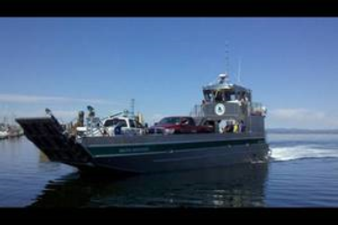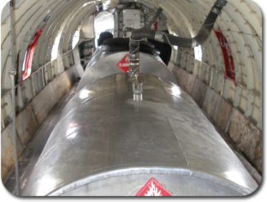

Vitus Marine Landing Craft

Inside of Alaska Air Fuel Flying Tanker

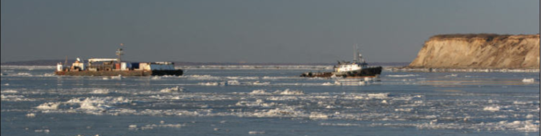

Delta Western Tug and Fuel Barge

In larger communities, the costs are divided up amongst more customers, making for a lower rate per customer. **Landlocked** communities with a small populations and communities experiencing school closures face the most extreme costs with few customers to share those costs. These utilities must charge rates often exceeding $1.00/kWh. They suffer **exponentially** (that means “double bad”) when the price of fuel rises, too. The highest rate we know of is $1.77/kWh. That’s double bad indeed.

Practice calculating the cost of power by completing the worksheet *Calculating the Cost of Power - Multiplying Money by 3 and 4-Digit Numbers.*  Use the *Customer Meter Photos* for the worksheet.

## Activity: The Power Cost Equalization Subsidy – Subtracting Money

Standards:

Example: $330.36 Cost of Power (529 x $0.6245)

- 165.15 PCE Subsidy (529 x $0.3122)

$165.21 Due from Customer

Customer used 529 kWhs. Full Rate is $0.6245/kWh. PCE Subsidy for first 750 kWhs is $0.3122/kWh.

**Background:**

Government assistance and subsidies are necessary to successfully provide consistent, affordable, and reliable power in remote locations across the planet. Alaska is no exception.

The **Power Cost Equalization (PCE)** is not a handout to rural Alaska, though, because the whole state needed assistance in the early years of developing energy **infrastructure** (things like power plants and distribution lines).

The PCE program was formally established in 1985 to assist rural residents when state funds were being used to construct major energy projects that would assist **urban** (city) areas. Most urban and road-connected communities were benefiting from major state-**subsidized** (paid for) energy projects such as the [Four Dam Pool](http://energy-alaska.wikidot.com/four-dam-pool) and [Bradley Lake](http://energy-alaska.wikidot.com/bradley-lake-hydroelectric-project) hydropower projects, and the Alaska Intertie to connect urban communities along the railbelt. To help spread benefits to more remote communities PCE funds are distributed to eligible utilities, which in turn reflect the state payment by lowering monthly bills to individual customers. The program insures the viability of the local utility and the availability of central station power to all residents.

Residential customers get a portion of their monthly usage paid for by the State - up to 500 kWhs per month until July 1, 2022 when the maximum amount was raised to 750 kWhs. Community Facilities, buildings/offices/infrastructure that benefits everyone in the community, are eligible to have all their kWhs subsidized – up to the community “quota” (limit). The community quota is determined by multiplying the latest State approved population by 70. For instance, if the population of a community is 195 the community can subsidize 13,650 kWhs (195 x 70) each month for facilities such as the water/sewer plant, government offices, laundry facilities, fire department, or public safety building.

How much the State will help cover the cost of power is based on an annual report the utility must give to the RCA. High costs generally lead to a higher PCE subsidy rate. But that’s only true if the utility keeps good records and knows what to report.

Practice subtracting money by completing the worksheet *The Power Cost Equalization Subsidy – Subtracting Money*. Use the *Customer Meter Photos* to complete the worksheet.

**Advanced Practice** : Worksheet *Ledger Math.*

## Activity: Averages, Weighted Averages, and the Price of Fuel

Standards:

**Background:** The RCA uses what’s called the “weighted average” price of fuel when calculating a PCE rate. That just means you must measure whatever fuel you have on hand and calculate the value at its average price per gallon as previously approved by the Regulator Commission of Alaska (RCA) then add the number of new gallons at their price when calculating the price of fuel.

To find an average, you add up all the numbers then divide by how many numbers there are.

**Example:** 3,200

6,400

3,200

+12,800

25,600 divided by 4 = 6,400

The numbers below are gallons of fuel delivered to the utility over the last month. Fuel delivered on different days can change in price. What is the average price of all the new fuel?

**Gallons Price/Gal. Total Cost**

**Example:** 3,200 x $3.8599 = $12,351.68

6,400 x $3.6789 = $23,544.96

3,200 x $3.8995 = $12,478.53

+12,800 x $3.8369 = $49,112.32

**25,600** **$97,487.49**

The **average price per gallon** is the total cost divided by the total number of gallons.

$97,487.49 divided by 25,600 gallons = **$3.8081**.

Using the example above, what would the weighted average price of fuel on hand be if you had 5,712 gallons with an average price of $4.2535/gallon before the delivery?

**Value of Fuel**

**Gallons On-Hand Total Value**

Example: 5,712 $4.2535 $24,295.99

+ 25,600 x 5,712 + $97,487.49

**31,312**  $24,295.99  **$121,783.48**

**Weighted Average Price of Fuel** = Total Cost / Total Gallons

$121,783.48 divided by 31,312 gallons = **$3.8894**

The tank farm manager should always “dip the tanks” before adding new fuel so the utility manager has an accurate number for the fuel report to the RCA. That sometimes means a person must climb up to the top of a fuel tank, open a lid, and insert a really big measuring stick. Tanks come with a chart to show how many inches equals how many gallons. Newer fuel tanks have gauges to show how much is in them. But those gauges can fail, so having a big stick around is a good idea.

Complete the worksheet *Averages, Weighted Averages, and the Price of Fuel* and *How to Convert Inches to Gallons.*

Activity: Make a measuring ‘dip’ stick for your tank at home or for someone you know needs one in the community.

Materials:

Clippers, knife or debarking tool, sharpie

Measure a 50 gal drum with another stick or a ruler. Explain that you want the stick to touch the bottom of the tank. If you dip the stick into the tank, touching the bottom and lift the stick straight out to see a line of fuel half way in the middle what information does that give you?

Also explain that you don’t want any debrie mixed in the tank so it is important that your stick is debarked and cleaned. Once students have a long, debarked stick, have them find the halfway and quarter marks. Create notches with a knife or mark with a marker to help make estimates of how much fuel is left in the tank.

## Activity: Depreciation - Dividing money by 1 and 2-digit divisors

Standards:

**Background:** When a utility buys equipment worth more than $500, the RCA expects the utility to **depreciate** the **asset.** If a utility overhauls a gen-set, the RCA expects the utility to **amortize** the cost.

Depreciation and amortization work the same, but amortization is used for assets that you can’t exactly touch such as overhauls of gen-sets or training for employees or more than a year’s worth of antifreeze or filters. The costs are generally divided into 3 years or less while equipment is depreciated. The RCA has a list of equipment and repairs and how long they should last.

Example: $30,000 divided by 20 = $1,500

The utility bought 10 meters for $300 each. Meters are expected to last 20 years. The full price of the meters ($300 x 100) equals $30,000. $30,000 divided by 20 equals $1,500. So, each year the utility gets to depreciate $1,500 for those meters.

* Explain that depreciating and amortizing are also something that students will do when they file their taxes after they turn 18. They can ‘write off’ assets that will depreciate over time to save money on taxes owed. If they choose to operate a business learning about assets that you can depreciate will help their business save money in taxes owed.

**Vocabulary**

**Amortize** – to spread the value of an **intangible** asset over a number of years

**Asset –** something of verifiable value

**Depreciate –** to spread the cost of a **tangible** asset over its useful life

**Intangible –** something of value with no physical presence

**Tangible –** real and able to be touched

Have students create a small book to help learn vocabulary terms. Write the vocabulary word and find a picture or draw a cartoon (simple sketch) of items you have now or would have in a future business. Share with the rest of the class.

## Activity: Fuel Efficiency – Division

Standards

**Background:** The invention of the **combustion engine** using liquid **fossil fuels** changed the world for mankind. But unless you live next to a fuel **refinery**, liquid fuel must be transported to a location near you to be useful for you.

I**mported** energy stored as liquid fuel costs a lot of money. Why?

* It takes fuel to transport it
* It is dangerous to transport and expensive to store
  + It is explosive, flammable, and toxic to the environment if spilled
* A lot of hands “touch it” from the time it leaves the ground until the time it reaches you
  + **Extraction** Industry
  + Refiners
  + Pipelines/Shippers (Trains, Trucks, Planes)
  + Vendors
* Burning fossil fuels adds to **atmospheric** CO2, increasing global temperatures and acidifying the world’s oceans

Traditional subsistence hunters and gatherers always try not to waste food – to use everything efficiently. Power generation should also be as efficient as possible, so the utility doesn’t import and store any more fuel than necessary to make electricity.

Fuel efficiency is calculated by dividing the total number of kWhs generated by the diesel generators by the number of gallons of diesel fuel consumed/used in the process.

Example:

455,500 kWhs Generated and 40,927 Gallons Consumed

455,500 divided by 40,927 = 11.13 kWhs Generated/Gallon

The RCA has set standards for fuel efficiency. If not met, the RCA will reduce the number of gallons used as if the goal were met. This reduction will decrease the PCE subsidy, thus raising the cost of utility services (fuel, electricity).

For a utility that uses diesel fuel to generate more than 80% of its total kWhs generated:

|  |  |
| --- | --- |
| **Annual Diesel Generation** | **Efficiency Standard** |
| < 100,000 kWhs | 9.5 kWhs/gallon of diesel fuel consumed |
| 100,000 – 499,999 kWhs | 10.5 kWhs/gallon of diesel fuel consumed |
| 500,000 – 999,999 kWhs | 11.5 kWhs/gallon of diesel fuel consumed |
| 1,000,000 – 9,999,999 kWhs | 12.5 kWhs/gallon of diesel fuel consumed |
| 10,000,000 + kWhs | 13.5 kWhs/gallon of diesel fuel consumed |

For a utility that uses diesel fuel to generate less than 80% of its total kWhs generated:

|  |  |
| --- | --- |
| **Annual Diesel Generation** | **Efficiency Standard** |
| < 100,000 kWhs | 8.5 kWhs/gallon of diesel fuel consumed |
| 100,000 – 499,999 kWhs | 10.0 kWhs/gallon of diesel fuel consumed |
| 500,000 – 999,999 kWhs | 11.0 kWhs/gallon of diesel fuel consumed |
| 1,000,000 – 9,999,999 kWhs | 12.0 kWhs/gallon of diesel fuel consumed |
| 10,000,000 + kWhs | 1. kWhs/gallon of diesel fuel consumed |

If a utility does not meet the standard, the following are some possible reasons:

* A math error (check your numbers)
* The total kWh meter at the power plant is not working properly
* The fuel meter at the power plant is not working properly
* There is water or a contaminant in the fuel
* Fuel filters need changing more often
* The gen-set used most often is too large for the load
* There is a repair needed
  + Fuel injectors need changing

**Vocabulary List:**

**Atmospheric** - pertaining to, existing in, or existing of the atmosphere (the air)

**Capacity** - the ability to contain

**Combustion engine** – any of various types of engines driven by energy produced by the act or process of burning fuel

**Extraction** - the act of pulling or drawing out (usually with special effort, skill, or force)

**Fossil fuels** - any combustible organic material, as oil, coal, or natural gas, derived from the remains of former life

**Imported** – something brought in from somewhere else

**Refinery** – an industrial plant to make petroleum free of impurities

## Activity: Line Loss – Subtraction and Division

**Background:** We measure generation and sales from meter readings. The difference between what is generated and what is sold is line loss. Some line loss is to be expected. As power travels on distribution wires not all of it makes it to the end customer. Some power loss as heat is expected during transmission.

The RCA has set 12% as the acceptable amount of line loss. Any more than that and the RCA will increase the number of kWhs Sold to achieve that 12%. This will decrease the community’s PCE rate.

If the line loss of any one month is lower than 0% there is definitely a math error. You can’t sell more power than you make. If it is higher than 12% there could be a maintenance problem needing attention. Investigate line loss every time. It could be a math error, but it could indicate a real problem needing repair.

Utilities that do not achieve the 12% **standard** for line loss get a reduced PCE subsidy. The RCA will add more kWhs to sales (they call it **impute**) to fix excessive line loss when calculating the PCE rate. This will lower the PCE subsidy rate for a utility’s customers.

The formula for calculating line loss is:

Total kWh Generated – (kWhs Sold + Station Service) divided by Total kWh Generated

For Example: 38,400 – (33,106 + 3,373) divided by 38,400 = Line Loss

38,400 – 36,479/38,400 = Line Loss

1921/38,400 = .05 Line Loss

.05 = 5% Line Loss

## Unit 3 Electric Utility Newsletter

While every electric utility would like to have a newsletter to keep customers informed of what is happening at the utility, oftentimes staff is too busy with other tasks. A student produced newsletter, done with the utility manager’s approval, is a great way to get students involved with the utility in a meaningful way.

All utilities that get PCE are required to notify customers of the previous month’s fuel efficiency in a format similar to that below.

**FUEL EFFICIENCY NTOICE TO CUSTOMER**

For the most recent monthly reporting period under the State of Alaska’s power cost equalization (PCE) program, this utility’s actual fuel efficiency for our community was _____ kilowatt-hours per gallon (kWh/gal). The applicable fuel efficiency standard set out in regulations for the PCE program is _____ kWh/gallon.

While this fuel efficiency notice is the main reason to make the flyer, it’s a good opportunity to share other interesting information about the utility or stories of historical interest. Students of all ages can contribute.

**Suggested flyer content in addition to Fuel Efficiency:**

* Line Loss
* Student drawings related to electric generation, transmission, use
* Short stories about ways to conserve electricity
* Short stories related to life before central power
* Updates on utility upgrades or maintenance
* Profiles of utility staff

See the *Sample Newsletter* for Kokhanok Electric. We used Word to produce the newsletter and used 2 columns.

## 

## Worksheet: Pre-Utility Site Visit Vocabulary

**_______ Diesel Engine Generator Set / “Gen-Set”**

**_______ Distribution System**

**_______ Microgrid**

**_______ Power Cost Equalization (PCE)**

**_______ Transformer**

**_______ Urban**

A. a network of wires that carries power from the generation plant to customers within a limited area

B. of, relating to, or designating a city or town

C. subsidy provided by the State of Alaska to “equalize” the cost of power between rural communities and Alaska’s Railbelt utilities.

D. the combination of a diesel engine with an electric generator to generate electrical energy

E. lowers the power voltage from primary lines to a usable level for customer appliances, equipment and lighting; one transformer can service several customers through *secondary* distribution lines

F. a generating and distribution system that serves a small geographic area

## Worksheet: My Electric Utility

**Name: ______________________________________ Date: _________________**

**Community Name: _________________________________________________**

**Current Population: _______________**

1. The name of my electric utility is _____________________________________.

Phone Number: ____________________________

Mailing Address: ____________________________

____________________________

**ADMINISTRATIVE INFORMATION**

2. The utility manager is ________________________________________________

3. The utility clerk(s) is (are): _____________________________________________

____________________________________________________________________

4. The price of electricity is ______________ /kWh.

5. The **Power Cost Equalization** rate is _______________ /kWh.

6. The utility serves _______________ customers.

_________ Residential __________ Commercial __________ Community Facilities _________ Federal/State ___________ Unbilled

**OPERATIONS AND GENERATION INFORMATION**

7. Our electric plant uses _________ diesel generators to make the power for our community.

#1 _____________ kW Make/Model: _________________________________________

#2 _____________ kW Make/Model: _________________________________________

#3 _____________ kW Make/Model: _________________________________________

#4 _____________ kW Make/Model: _________________________________________

#5 _____________ kW Make/Model: _________________________________________

#6 _____________ kW Make/Model: _________________________________________

7a. Our electric utility also generates electricity with:

Hydropower __________ kW generation plant

Wind turbine(s) __________ (number of turbines) _____________ kW (size of turbines)

8. The lead power plant operator is: ___________________________________.

His work phone number is: _____________________________________.

9. Power plant assistant operator(s): _____________________________________________

_____________________________________________

10. Power plant intern(s):______________________________________________________

_____________________________________________

11. Ask the power plant operator to show you where the power leaves the power plant on its way to the homes and other buildings in the village.

On the back of this sheet, draw a picture of the power plant from the perspective of a bird flying over. Show where the power comes out of the building on its way to customers. Label the directions N, S, E, and W on your drawing.

12. Ask the plant operator to show you a transformer and explain to you what it does.

Write the explanation here:

______________________________________________________________________________

______________________________________________________________________________

___________________________________________________________________

## Worksheet: Electric Utility Jobs

Have students write the name of the person who does each job. More than one may be done by the same person. Have each student choose one person from the utility staff to interview about their job. Make sure all staff members get chosen, because each job is vital to the success of the utility.If there are more students than staff, have students work in pairs or groups.

|  |  |
| --- | --- |
| **Job Title** | **Local Personnel** |
| Utility Manager |  |
| Utility Clerk |  |
| Bookkeeper |  |
| Lead Power Plant Operator |  |
| Assistant Power Plant Operator |  |
| Meter Reader |  |

Some sample questions:

* What subject in school was the most helpful to you in your job now?
* What activities might you do during a typical day at work?
* What is your favorite part of your job?
* What is your least favorite part of your job?
* Are there classes or trainings available to help you get better at your job?
* Do you get a pay raise if you stay on the job for years or get more training, so you can do a better job?
* How many hours do you work a day?
* How many days a week do you work?
* Are you required to be “on-call”?

## Customer Meter Photos – Quyana to Akiak Power Company!

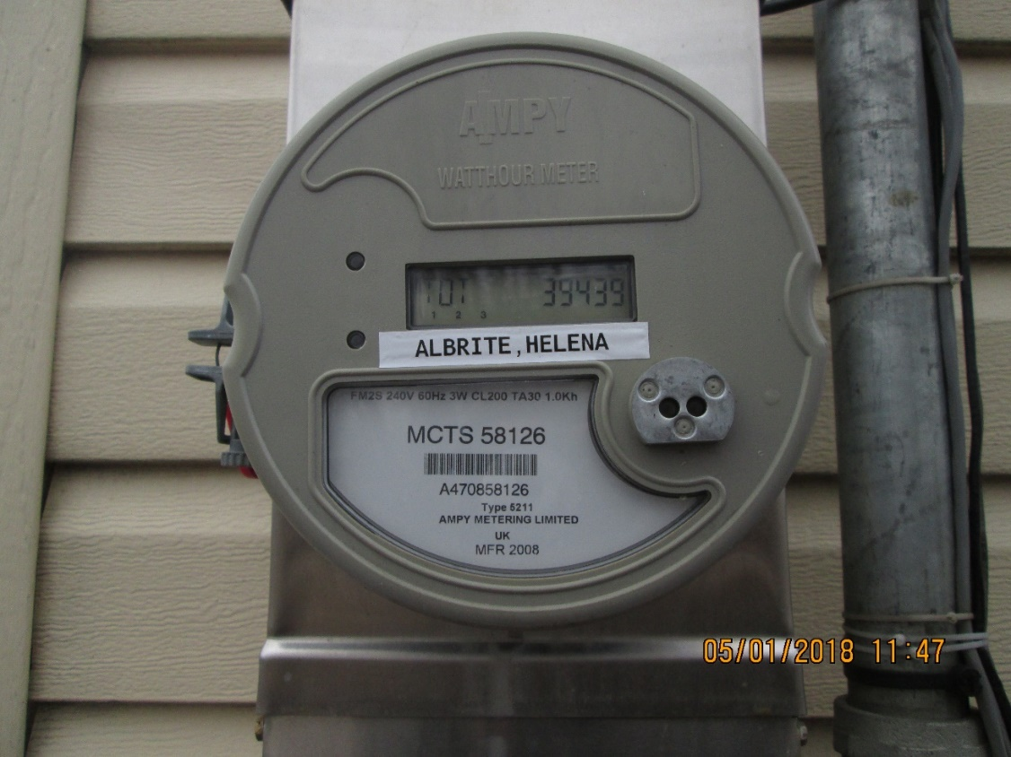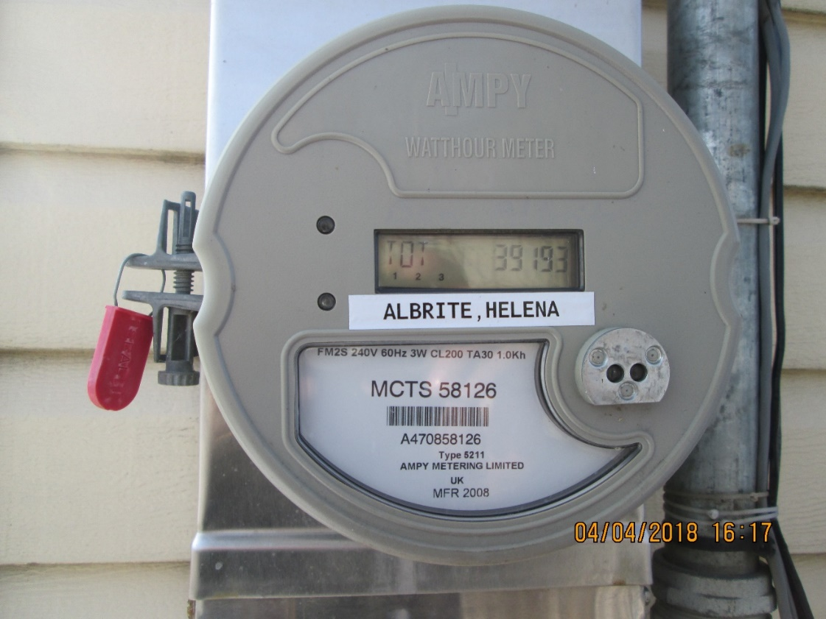

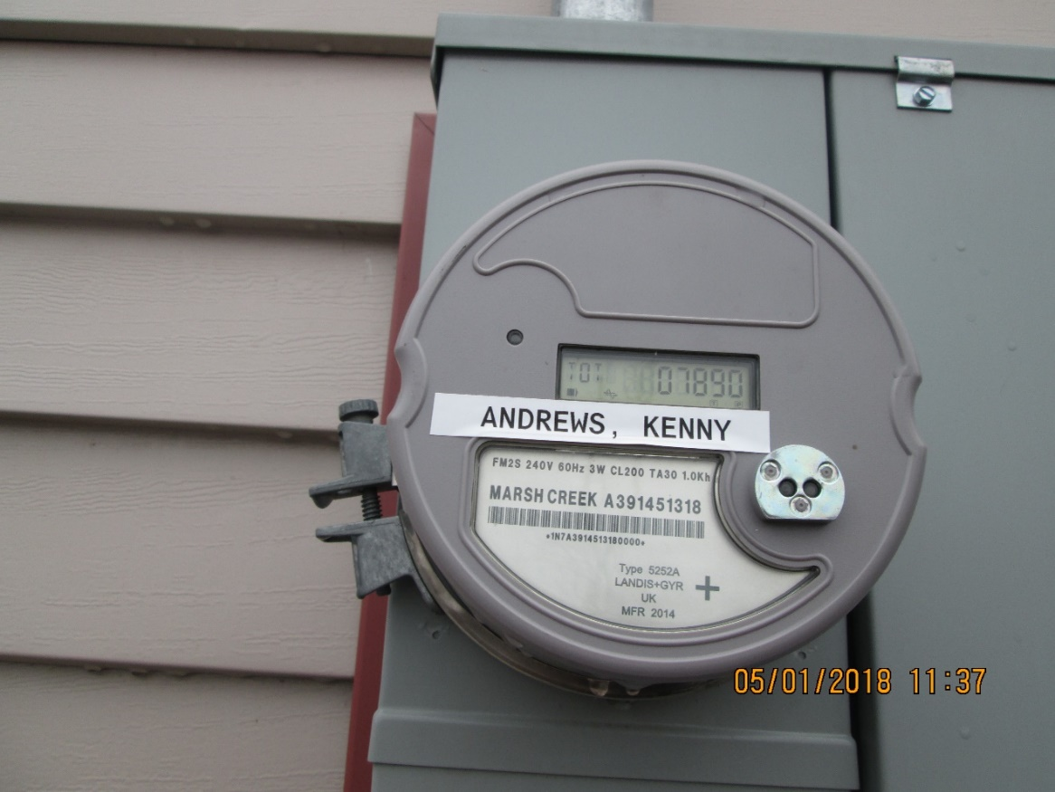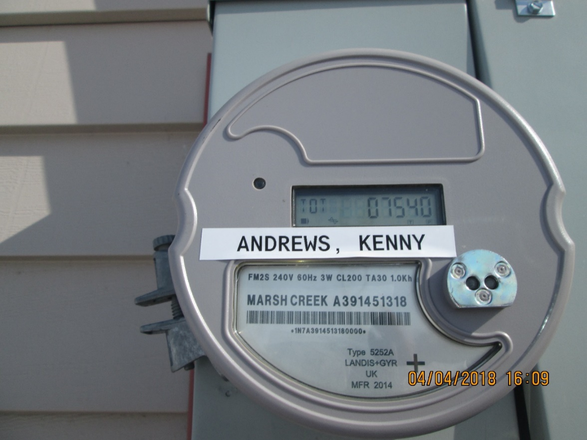

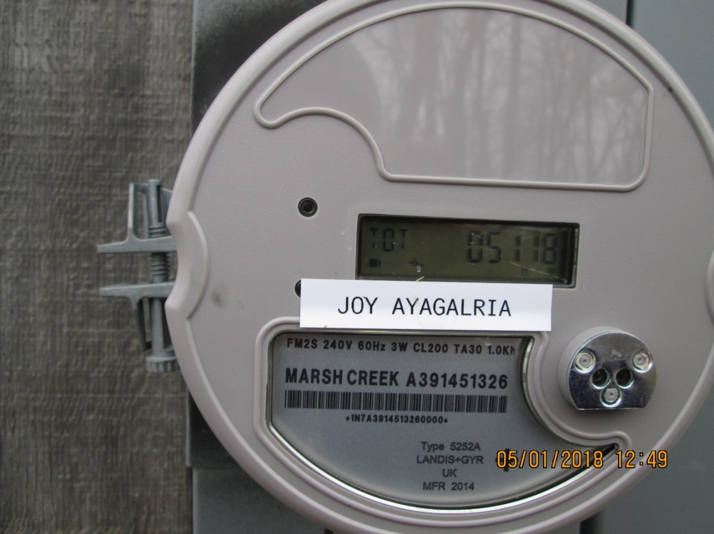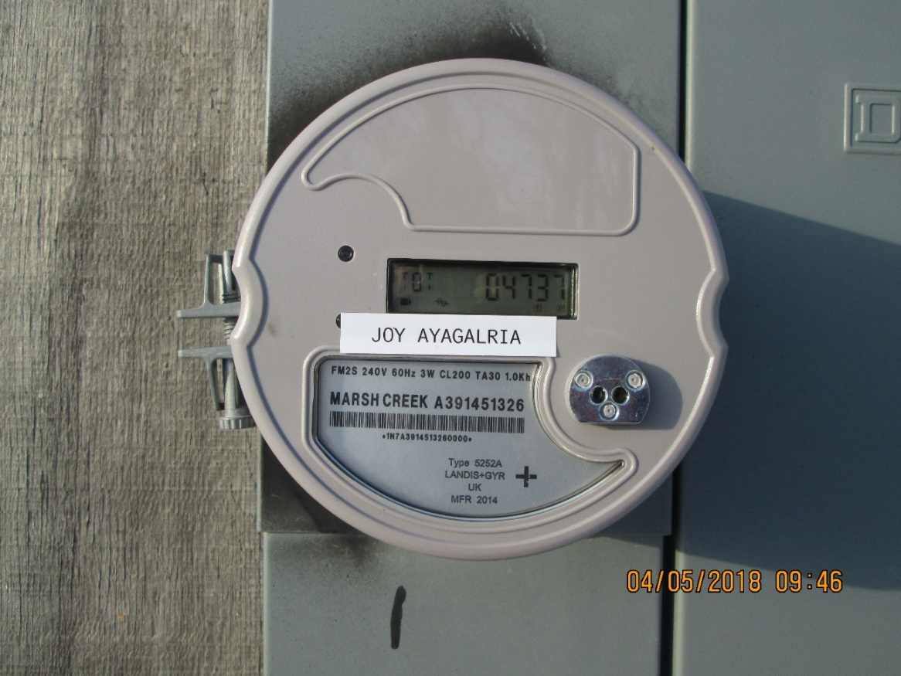

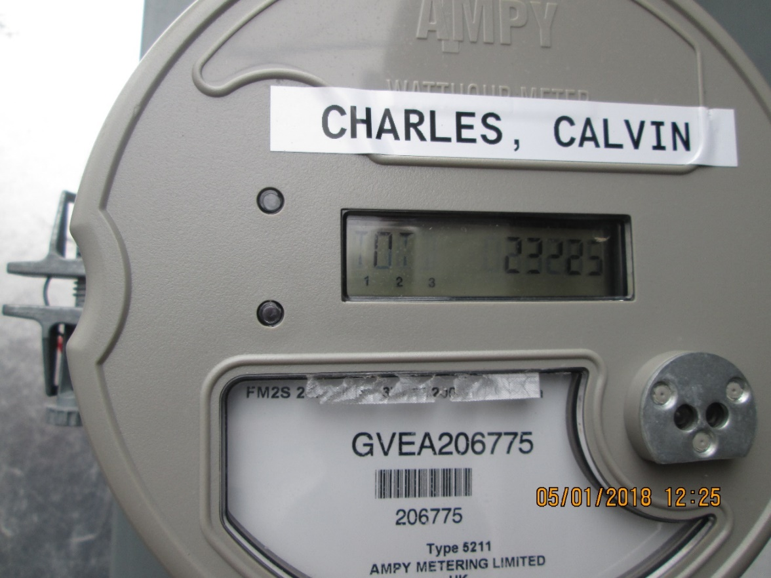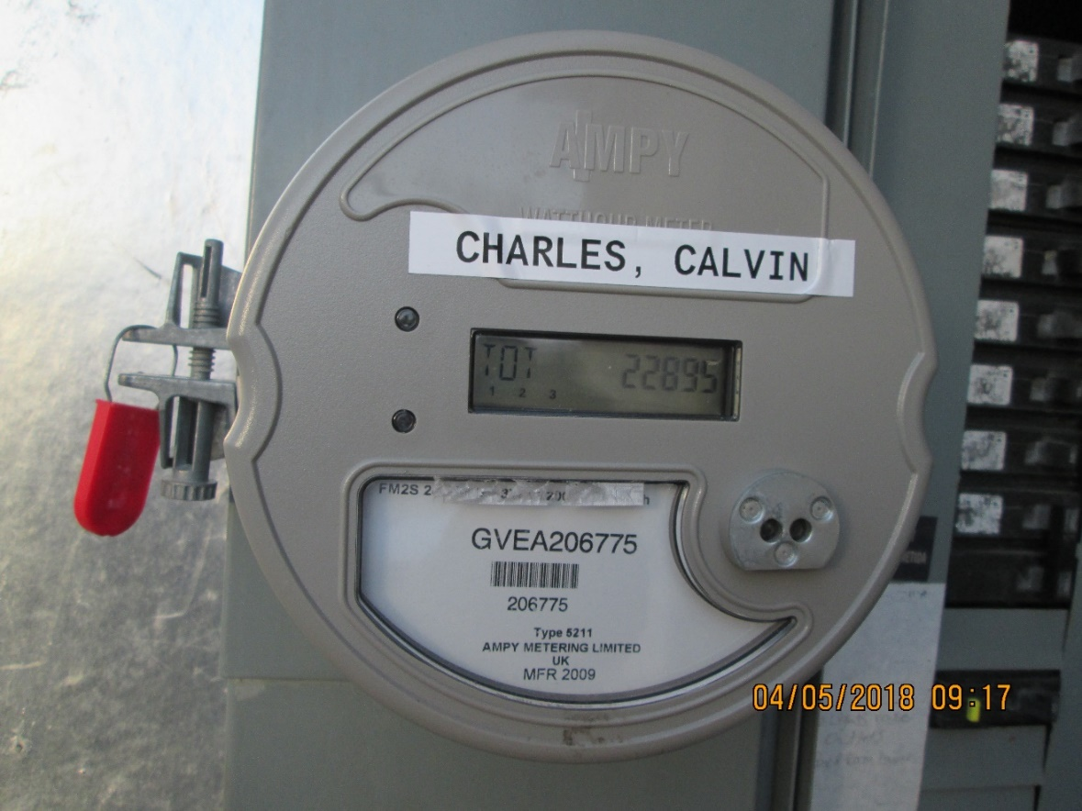

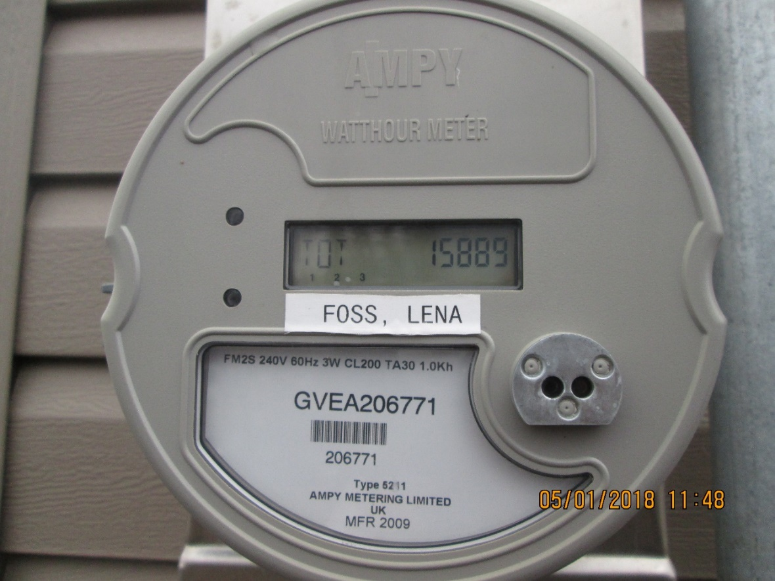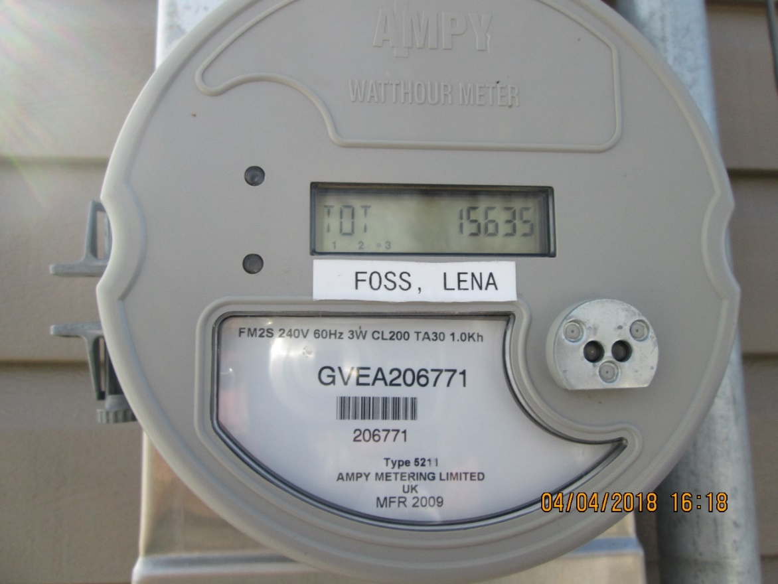

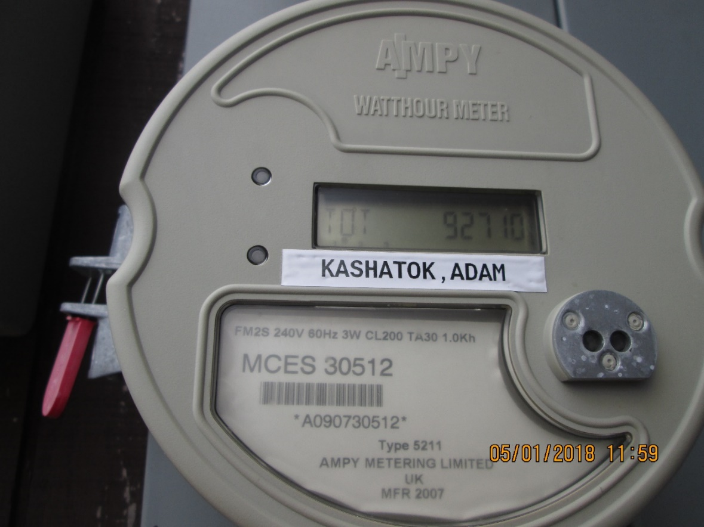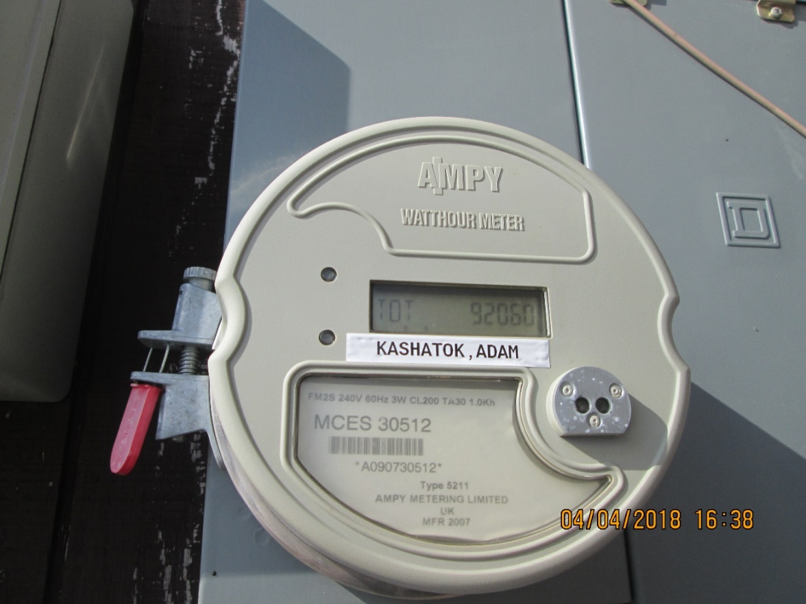

## Worksheet: Usage Calculation - Subtraction with 5 Digit Numbers

1. Helena’s meter reading at the beginning of April was __ __ __ __ __. On the first of May her meter reading was __ __ __ __ __. How much electricity did Helena use over the last month?
2. Joy’s meter reading at the beginning of April was __ __ __ __ __. On the first of May her meter reading was __ __ __ __ __. How much electricity did Helena use over the last month?
3. Kenny’s meter reading at the beginning of April was __ __ __ __ __. On the first of May his meter reading was __ __ __ __ __. How much electricity did Kenny use over the last month?
4. Calvin’s meter reading at the beginning of April was __ __ __ __ __. On the first of May his meter reading was __ __ __ __ __ __. How much electricity did Kenny use over the last month?
5. Lena’s meter reading at the beginning of April was __ __ __ __ __. On the first of May her meter reading was __ __ __ __ __ __. How much electricity did Kenny use over the last month?

*Think about it…*

Last month Tommy used 390 kWhs. His meter reading this month was 76450. What was his meter reading last month?

## Information Sheet: Customer Rate Classes

Customers are billed based on how many kWhs are used within a one-month period. Usage is calculated by subtracting last month’s meter reading from this month’s meter reading.dxrzs

Customer rates,the dollar amount charged per kWh of usage**,** are tied to their Rate Class. The PCE Program uses these 5 rate classes:

|  |  |  |
| --- | --- | --- |
| **RATE CLASS** | **DESCRIPTION** | **EXAMPLES** |
| **Residential (R)** | a home or apartment where people live and do not do a major business (Alaska PCE rules state that no more than 25% of a residence may be used for Commercial activities.) |  |
| **Commercial (C)** | a building, or space within a building, where goods are sold or business is done | Store, church, processing plant, corporation office, community school |
| **Community Facility (CF)** | a building or space that benefits everybody in the community | Pump house, fire hall, tribal office, city office, clinic, VPSO office, sewer system, tank farm, community center, streetlights |
| **Federal/State** **(F/S)** | a building or space that is paid for by either the State of Alaska or Federal Government | Post Office, Automated Weather Observation Station (AWOS), Federal Aviation Administration (FAA), Department of Transportation (DOT) |
| **Unbilled** **(UB)** | a customer the utility chooses not to charge for power | Churches, clergy’s home |

Rate Classes may have different rates, but customers within a Rate Class must all have the same rate (although larger users, such as schools or processing plants, may get a reduced rate within their rate class).

## Worksheet: Calculating Cost of Power - Multiplying Money by 3 and 4-Digit Numbers

1. Look at Adam’s meter readings from early April to May 1st. How many kWhs did he use? His utility charges $.90 for electricity. How much money does he owe for the power he used in April?

1. Look at Helena’s meter readings from early April to May 1st. How many kWhs did she use? Her utility charges $.1.00/kWh for electricity. How much money does she owe for the power she used in April?
2. Look at Kenny’s meter readings from early April to May 1st. How many kWhs did he use? His utility charges $.6640 for electricity. How much money does he owe for the power he used in April?
3. Look at Lena’s meter readings from early April to May 1st. How many kWhs did she use? Her utility charges $.67/kWh for electricity. How much money does she owe for the power she used in April?
4. Look at Joy’s meter readings from early April to May 1st. How many kWhs did she use? Her utility charges $.85/kWh for electricity. How much money does she owe for the power she used in April?

## Worksheet: Power Cost Equalization Subsidy - Subtracting Money

1. Look at Adam’s meter readings from early April to May 1st. How many kWhs did he use? His utility charges $.90 for electricity. How much money does he owe for the power he used in April? The PCE rate for his community is $.6555. How much does Adam owe the utility after PCE? *(hint: PCE only covers the first 750 kWhs used in a month)*

1. Look at Helena’s meter readings from early April to May 1st. How many kWhs did she use? Her utility charges $.1.00/kWh for electricity. How much money does she owe for the power she used in April? The PCE rate for her community is $0.7830. How much will Helena owe the utility after PCE?
2. Look at Kenny’s meter readings from early April to May 1st. How many kWhs did he use? His utility charges $.6640 for electricity. How much money does he owe for the power he used in April? The PCE rate for Kenny’s utility is $0.3122. How much will she owe the utility after PCE?
3. Look at Lena’s meter readings from early April to May 1st. How many kWhs did she use? Her utility charges $.67/kWh for electricity. How much money does she owe for the power she used in April? The PCE rate for her utility is $0.3568. How much will Lena owe the utility after PCE?
4. Look at Joy’s meter readings from early April to May 1st. How many kWhs did she use? Her utility charges $.85/kWh for electricity. How much money does she owe for the power she used in April? The PCE rate for Joy’s utility is $0.3739. How much will she owe the utility after PCE?

## Worksheet: Depreciation - Dividing money by 1 and 2-digit divisors

1. The utility bought a new diesel gen-set for $50,000. Gen-sets are expected to last 14 years. How much will the utility be able to count as an expense each year for 14 years?

2. The utility got a great deal on lube oil and bought enough for the current year plus next. How much will the utility be able to count as an expense each year if the total cost was $5,500?

3. Total overhaul of a gen-set is expected to benefit the utility for 5 years. The cost of the overhaul was $24,000. How much will the utility be able to count as an expense each year for 5 years?

4. An electric utility needed a new bucket truck for working on transformers and the distribution system. The new truck was used, but with the cost of transporting it to the community cost $36,000. The RCA set the expected life of a vehicle for 4-6 years. How much will the utility be able to count as an expense each year? *(hint: because the vehicle is used, the lower life span is suggested)*

5. The utility had to replace overhead lines for half the town. The total cost was $1,000,000. Overhead lines are expected to last for 25 years. How much will the utility be able to count as an expense each year?

## Worksheet: Fuel Efficiency - Division

1. Last month the utility generated 45,000 kWhs of power using 4,000 gallons of fuel. What is the fuel efficiency for the month?

2. Last year the utility generated 455,500 kWhs of power using 40,927 gallons of diesel. What is the fuel efficiency for the year?

3. In February the utility used 3,481 gallons of fuel to generate 42,800 kWhs of power. What was the fuel efficiency?

4. In December the utility generated 43,500 kWhs of power and used 3,729 gallons of diesel. What was the fuel efficiency in December?

5. In July the utility used 2,635 gallons of diesel to produce 28,100 kWhs of power. What was the fuel efficiency in July?

## Worksheet: Line Loss – Subtraction and Division

## 1. In January the utility produced 43,100 kWhs of power. The Station Service was 3,800 kWhs. The utility sold 36,086 kWhs to customers. What was the line loss in January?

2. In April the utility sold 30,735 kWhs to customers. The utility generated 35,400 kWhs and the power plant itself used 3,195 kWhs. What was the line loss in April?

3. In June the utility generated 26,900 kWhs of power while the plant used 3.,097 kWhs. 23,433 kWhs of power was sold to customers. What was the line loss in June?

4. In August the utility sold 28,358 kWhs of power while generating 32,100 kWhs. The station service was 3,199 kWhs. What was the line loss in August?

5. In December the utility generated 43,500 kWhs of power. Station Service was 3,501 kWhs and 38,410 kWhs of power was sold. What was the line loss in December?

## ANSWER KEY

Worksheet: Pre-Utility Site Visit

D, A, F, C, E, B

Worksheet: Usage Calculation - Subtracting 5-Digit Numbers

1. 39439 – 39193 = 246

2. 5178 – 4737 = 441

3. 7890 – 7540 = 350

4. 23225 – 22895 = 330

5. 15889 – 15635 = 254

Think about it: 76450 – 390 = 76060

Worksheet: Calculating Cost of Power - Multiplying Money

1. 650 x $0.90 = $585.00

2. 246 x $1.00 = $246.00

3. 350 x $0.664 = $232.40

4. 254 x $0.67 = $170.80

5. 441 x $0.85 = $374.85

Worksheet: Power Cost Equalization Subsidy – Subtracting Money

1. $585 – (650 x .6555) = 426.08

$585 - $426.08 = $158.92

2. $246 - $192.62 = $53.38

3. $232.40 - $109.27 = $123.13

4. $170.18 - $90.63 = $79.55

5. $374.85 - $164.89 = $209.96

Worksheet: Depreciation – Dividing Money by 1 and 2-digit divisors

1. $3,571

2. $2,750

3. $4,800

4. $9,000

5. $40,000

Worksheet: Fuel Efficiency – Division

1. 11.25 kWhs/gallon

2. 11.13 kWhs/gallon

3. 12.30 kWhs/gallon

4. 11.67 kWhs/gallon

5. 10.66 kWhs/gallon

Worksheet: Line Loss – Subtraction and Division

1. 7.5%

2. 4.2%

3. 1.4%

4. 3.7%

5. 1.7%